HMG series EO sterilizer
Computer system Operation manual
HMG系列环氧乙烷灭菌柜
计算机控制系统操作说明

Jiangyin Huaqing Machinery Co., Ltd
江 阴 市 华 青 机 械 有 限 公 司
Tel：0510-86514858 Fax：0510-86518900

Content 目录
1 Brief introduction 简介 3
2 features 特点 3
3 user manual 使用说明 3
3.1 program install 程序安装 3
3.2 program register 程序注册 3
3.3 main menus 主程序 5
3.3.1 User settings 用户设置 5
3.3.2 Set start step 设置启动步骤 7
3.3.3 Start 开始 7
3.3.4 Normal working 正常工作 8
3.3.5 Data 日志 11

brief introduction简介
EO Sterilizer is reserved for the use of low temperature sterilization with EO under particular condition of temperature, pressure and humidity. HMG-C series sterilizer is the third generation product which our company produces that adopts the advantages of similar products at home and abroad. The performance and quality are all conform to EN1422 standard, and provide technical support for customers.

features特点
The use of auto shift gate controlled by a cylinder, silica gel tube door seal makes the gas tightness well. Adjustable hexahedral heating system is adopted, so the sterilizing temperature is even inside to ensure the consistency of sterilizing effects. The YG type of pretreatment cupboard and preheat house control system are developed for supporting the use of customers.

user manual使用说明

program install程序安装
Double-click the provided install package ATCASx.x.msi
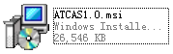, do as the interface prompts.

program register程序注册

If it is the first time you run the program, and the seller did not preregister for you, then you need to contact us for the Corresponding register code for your product.
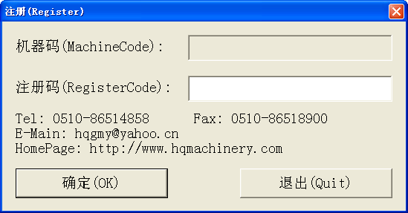
When the interface upon has appeared, it shows that you have not registered the product. Please contact us with the ways show below and provide us the machinecode the interface shows, then we will give you the corresponding registercode. The registercode is available for a long time, you should keep it and you can use it next time.
When registering, fill the registercode we provide in the input box of registercode and click OK button, if the registercode is correct, you will finish the register.

TEL: 0086-510-86514858
FAX: 0086-510-86518900
E-mail: hqgmy@yahoo.cn
Homepage: www.hqmachinery.com

main menus主程序

user settings用户设置

per load info settings批信息设置
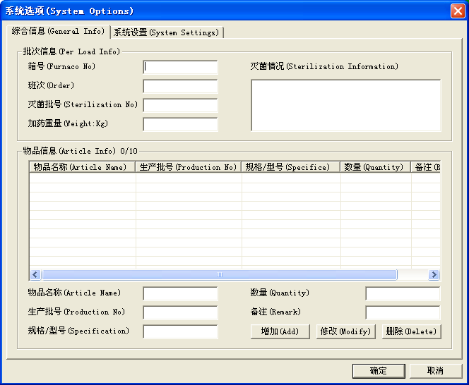
When entering the main menus, you need to set the information of per load and articles.
When adding articles, fill in the information of the articles first and click the “add” button on the right corner second, then the articles will be added to the list.
when modifying the added articles, choose the articles which need to modify first, and change the item information in the input box below, when modifying is finished, click the “modify” button and the information is changed.
When deleting the added articles, choose the articles which need to delete and click the “delete” button on the right corner, then the chosen article will be deleted.
After setting the per load info, please check and set the system.
- You can add as much as 10 articles; the number of the items you added will be counted behind the “article info” tag.
- After you adding the articles, you can click the title button in the item list (like “article name”) to sort the added articles.

system setting系统设置
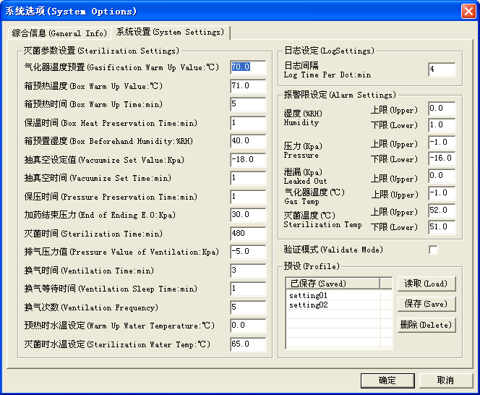
After setting the per load info, you need to set the parameters for this operation.
Please check the parameters one by one, if all are correct, then click the “OK” (确定) button and enter the main controlling interface.
When the parameters are set, you can click the “save” (保存) button to set this parameters as the default parameters. Next time, you just need to select the saved setting, then click the “load” button, the default parameters you saved will be used as the current settings.
- Log time per dot means when system is working, the interval between each two data collecting. After the log time per dot is set, please do not change it when system is working, but you can set the multiple of it when you are printing the data.
- Validate mode is used for collecting article temperature when the product is under testing, please do not tick it when normal working, when it is ticked, it would affect the data collecting and printing.

set start step设置启动步骤
Click the “startstep” button on the lower right corner, if you have not enter the per load info, it will ask you to enter the info first.
If you have set the info for this time, then the interface below for choosing step would show.
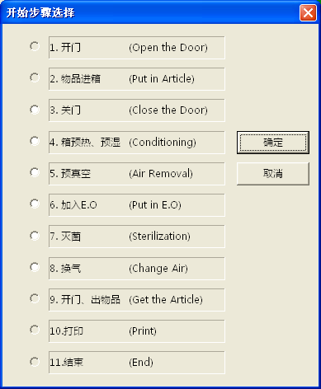
Tick the blank before the step you want to choose.
If you choose self-closing, please start from “3.close the door”, then click “确定” button, and a new button “start”(开始) will appear just by the side of “startstep”.
If you choose manually closed, please start from the steps below “3.close the door”, and a new button “start”(开始) will appear beside the “startstep”.

start开始
If you choose self-closing, after click “start”(开始), there must be an alarm signal for a short time, when the alarm is over, the door will self-closing.
If you choose manually closed, after click “start”(开始), it will start from the chosen step.

normal working正常工作
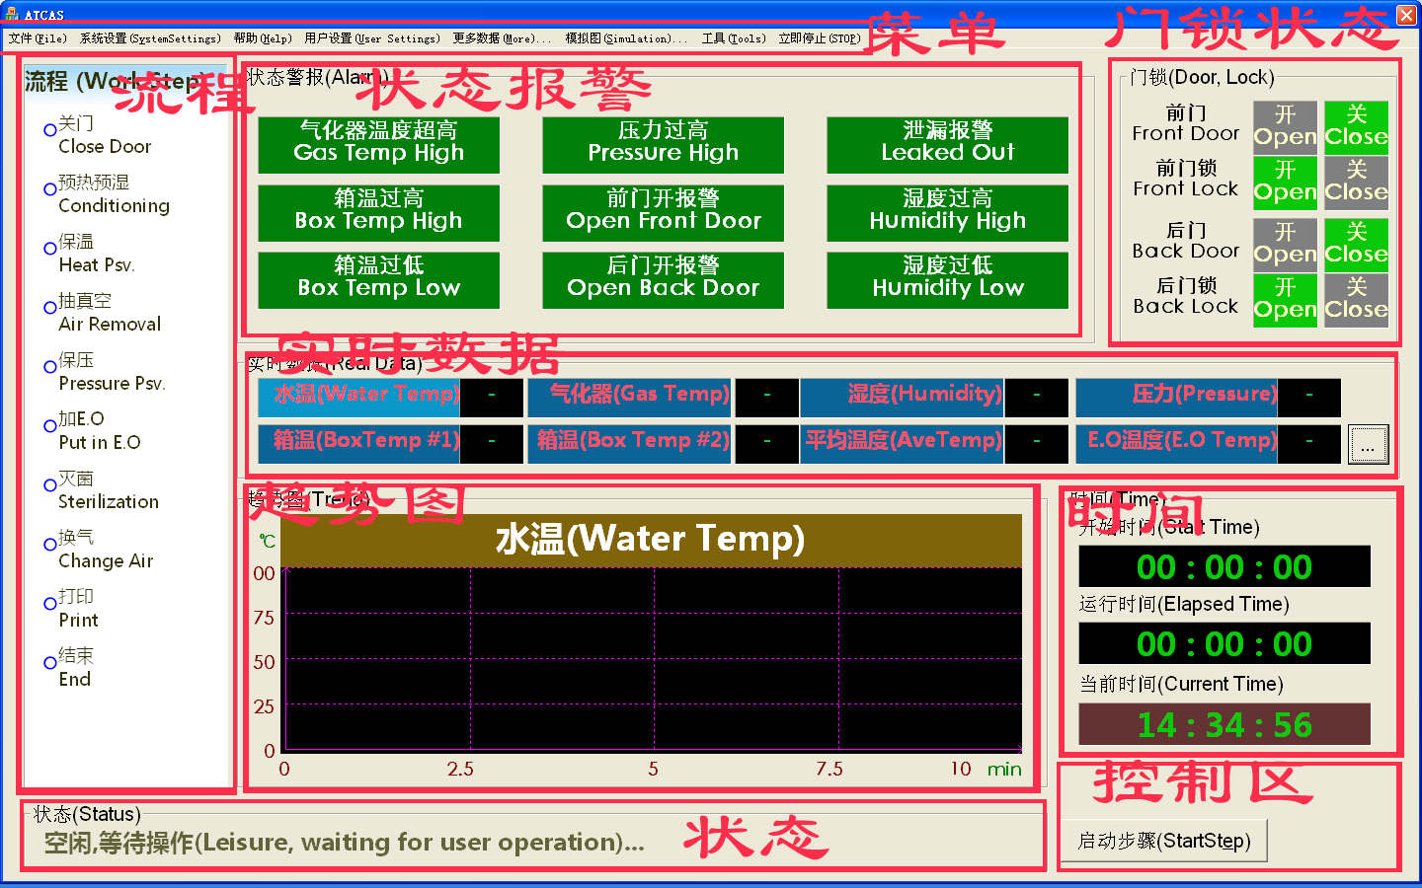
When the system is normal working, you can check the current progress and the real-time data information.

work step流程
In this area, you can see the current progress clearly, you also can find the time this step used and the time this step may remain.
- Because of some external factors, the time remains may not be correct, just used for consulting.

Alarm状态报警
In this area, if some unusual conditions appear in current step, it will flash to remind you and alarm will also be heard. Please follow the prompt to eliminate anomalies.

door, lock门锁状态
In this area, it shows the door is open or locked.

real-time data实时数据
In this area, it will show all the current data in the system.
If it is in the validate mode, click the “…” button in right or the “more” in the menu and then you can check the real-time information of the article temperature.
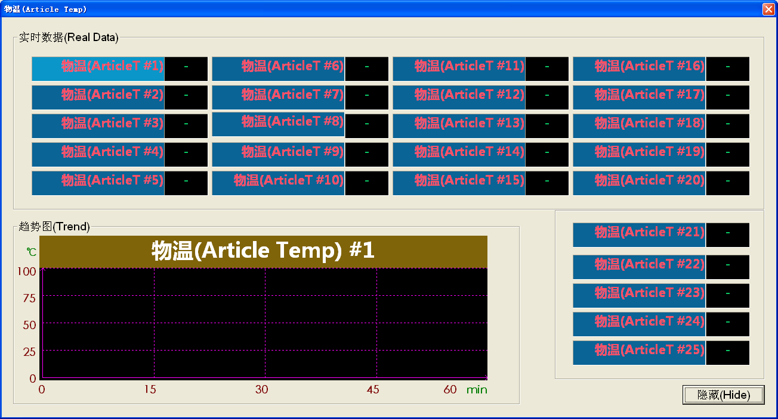

trends趋势图
In this area, it will show you the current data as trends, then you will have a overall concept of the data changing.

time时间
In this area, there are three kinds of time showing.
Start time: the time you click the “start” button, it shows the time the system begins working.
Elapsed time: the time passed till now after you click the “start” button.
Current time: the current system time.

status状态
In this area, it will show you the step the system is working on now.

controlled area控制区
In this area, you can choose the start step of the system and control the starting of the system; you can also notice the program that E.O has been added.

simulation模拟图
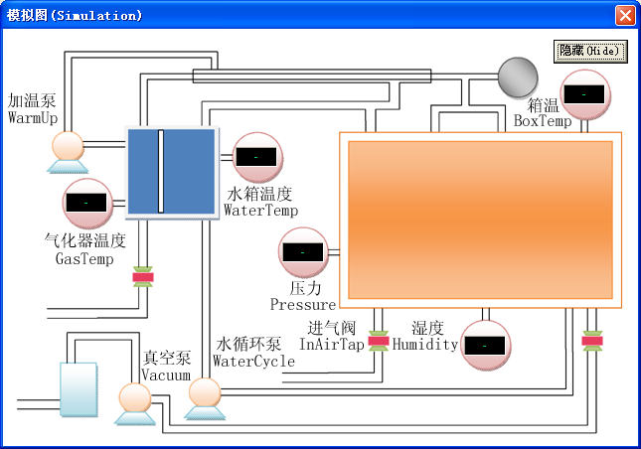
You can click the “simulation” button on the menu bar, and then you can use the simulation to monitor the system. In the simulation, it will show you the current status of the system depending on the current work the system is doing.

data日志

checking查看
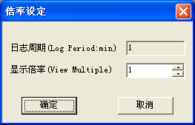
Click the buttons on the menu bar “tools”→”history data”(历史数据处理), you can open the interface for checking the data. You will be asked to choose the data you want to check. The data file is named an “YearMonthDayHourMinSec_Furnaco no.atl”.
The system will remind you to set the view multiple after you have chosen the data file.
Log period: the log time per dot of the data you choose.
View multiple: the multiple you want to check the data. The data will show the parameter with new log time per dot which is “log period * view multiple”.
You can check the data after these two are set.
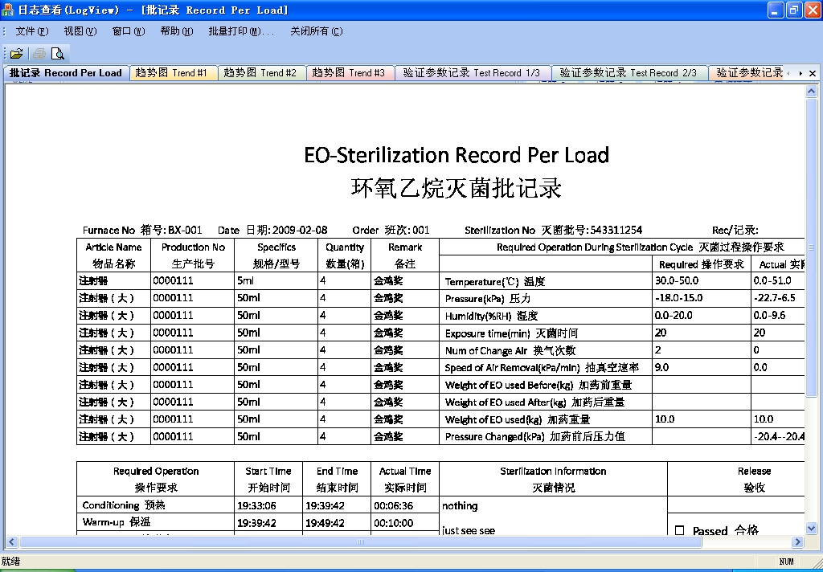

batch print批量打印
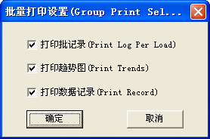
You can click the “M”(批量打印) on the menu bar in logview to print the data you are checking.
Print log per load: print the log per load or not.
Print trends: print the trends or not.
Print record: print the record or not.
Click “确定” after set this and the program will send the chosen part of the current data to printer.

single page print单页打印
You can print the current page you are checking through the button on menu bar: “F”(文件)→”print”(打印).

print settings打印设置
If you do not set it, the program will print the data using default printer.
If you need to use other printers to print the data, please choose the “F”(文件)→”打印设置” to set the printer.
- The setting is just available for the current interface and do not save. If you want it to be available for long time, please set the printer as the default printer.

check other data查看其它日志
If you need to check or print other data, choose the menu “F”(文件)→”open”(打开), it will show you the interface for choosing data to open other data.

